The result is similar to Stull (1988), durimg the day time, L is negative and night time is positive.

Fig 1.1 Obukhov length (L) diurnal cycle.

Around 6 a.m, the conditions switch from stable to unstable. Around 17.00 the conditions change from unstable to stable. This transition time is around sunrise and sunset. It is similar to the Fbv ig 1.2. It needs to sometime to accumulate the heat after sunrise, which is why the transition from stable to unstable is a little delay than sunrise.

Fig 1.2 daily cycle of the PBL

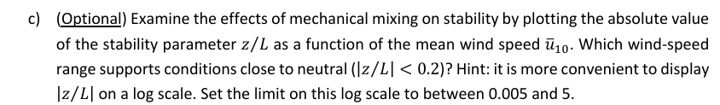

When the mean wind speed is larger than 4.3 m/s, it is neutral condition. When the mean wind speed is between 2.5 m/s and 4.3 m/s, it is could be neutral or unneutral conditions.

Fig 1.3 Mean wind speed at 10 m against |z/L|

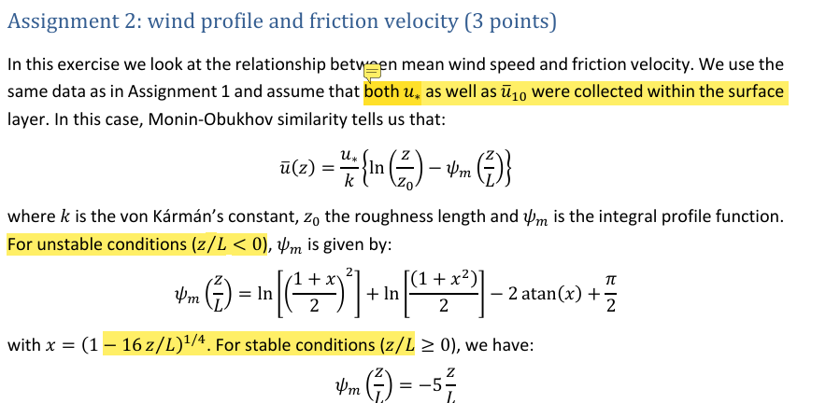

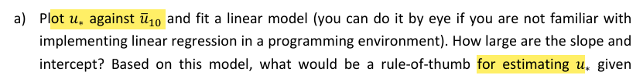

The slope is 0.0802, and the intercept is -0.0691. u* =0.0802 ${ \overline{u}}_{10}$-0.0691 can be used to estimate friction velocity when the ${ \overline{u}}_{10}$ is known. From Fig 2.1 we can see that the modelled u* is unestimated compared to the u* obatained by log wind profile.

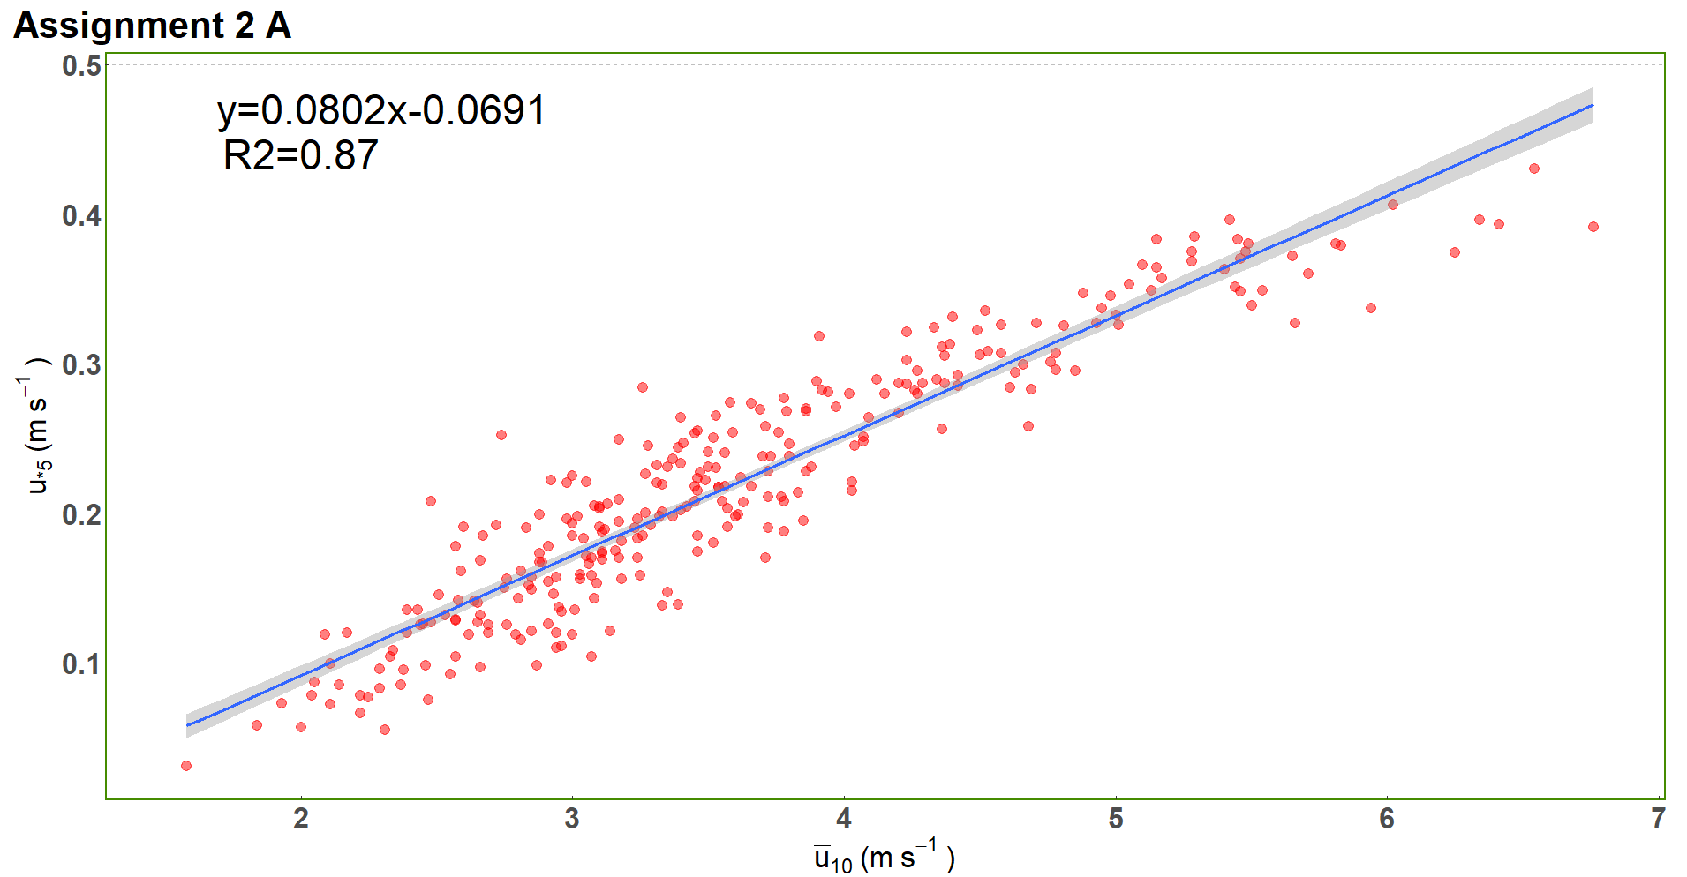

Fig 2.1 means wind speed at 10 meters against friction velocity at 5 meters

Fig 2.2 Y axis is the u* at 5 meters based on the model: u* =0.0802 ${ \overline{u}}_{10}$-0.0691, and x axis is obatained by log wind profile.

When the u*10 is smaller than 0.2 m/s, which is for stable condition, the data points scatter around the 1:1 line quite wel. However, the u*10 is overestimated compared to measured friction velocity. This maybe is related to our assumption that the friction velocity is the same at 5 meter and 10 meter in the surface layer?

Fig 2.3 Y axis is the u* at 5 meters measured, and x axis is obatained by a log wind profile considering the stratification conditions.

Fig 3.1 shows the fluctuation of u, w, v, and T time series. The order of magnitude of the fluctuation of each series is around 10-1 m/s or T

Fig 3.1 time series of u, w, v, and T. The black solid line represents the mean value.

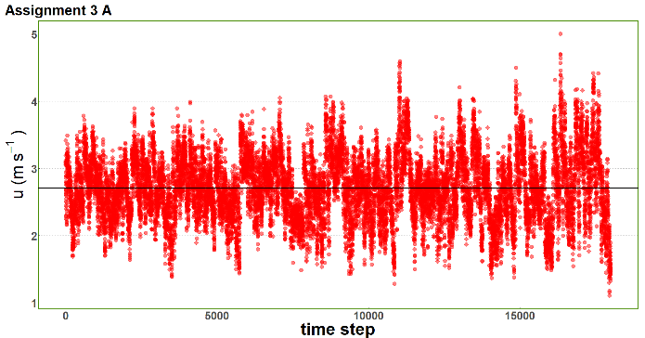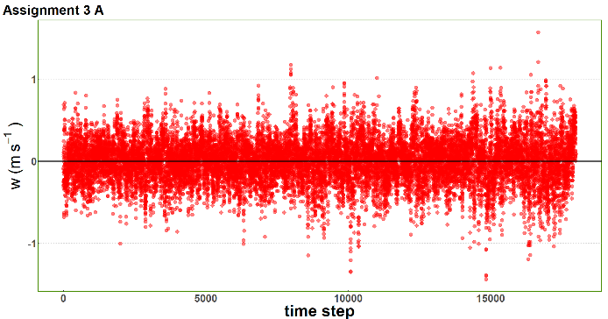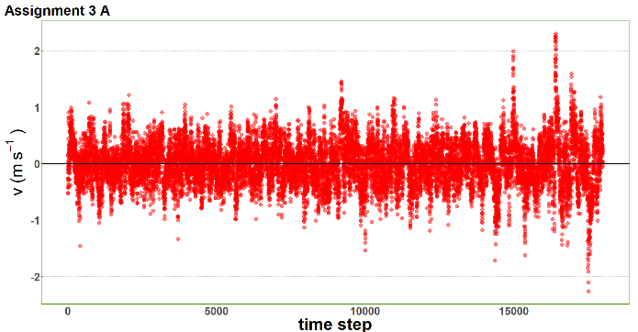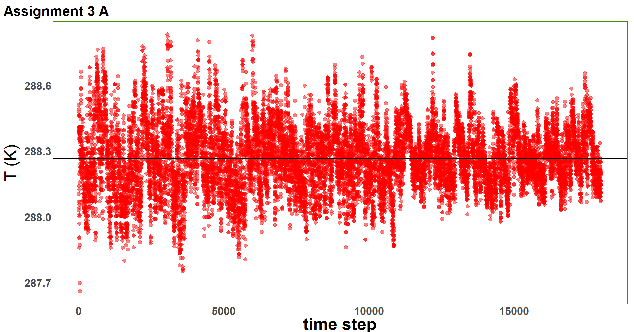

(a)

(c)

(b)

(d)

The relavent numbers are listed in table 3.1. The result verifies that we are in a streamline coordinate and consists with the graphs from a.

Table 3.1 The mean and standard deviation of the time series

|  |  |  |  |  |
| --- | --- | --- | --- | --- |
|  | u | v | w | T |
| Mean | 2.71 | 0.0005 | 0.0002 | 288.26 |
| Standard deviation | 0.50 | 0.39 | 0.26 | 0.15 |

Iu= 0.18, Iv= 0.14, Iw =0.098. TKE = 0.23 m2/s2. The TKE value is consistent with the Fig 6.1 in the lecture note considering the data are from early morning when transition from stable to unstable condition happens.

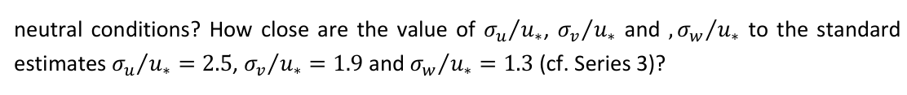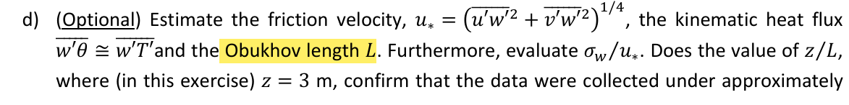

u* = 0.21, σw/u* = 1.27, z/L= 0.068, σu/u*= 2.36, σv/u*= 1.86. These numbers comfirm that the data were collected under approximately neutral conditions.

Integral_Su = 0.23, Integral_Sv = 0.14, Integral_Sw = 0.068,

In the assignment 3b, σ2u=0.25, σ2v = 0.15, σ2w=0.07, so with 15% of error, we can draw a conclusion that Integral_Su= σ2u, Integral_Sw= σ2w, Integral_Sv= σ2v

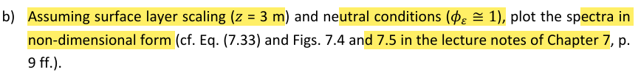

The results are shown in Fig4.1, Fig 4.2 and Fig 4.3. The x and y axis are in a logarithmic scale.

Fig 4.1 cospectra of S(u) in log scale

Fig 4.2 cospectra of S(v) in log scale

Fig 4.3 cospectra of S(w) in log scale

Well, I have no cludes on how to arrage these graphs, bu I would say the largest departure is found at the inertial subrange???

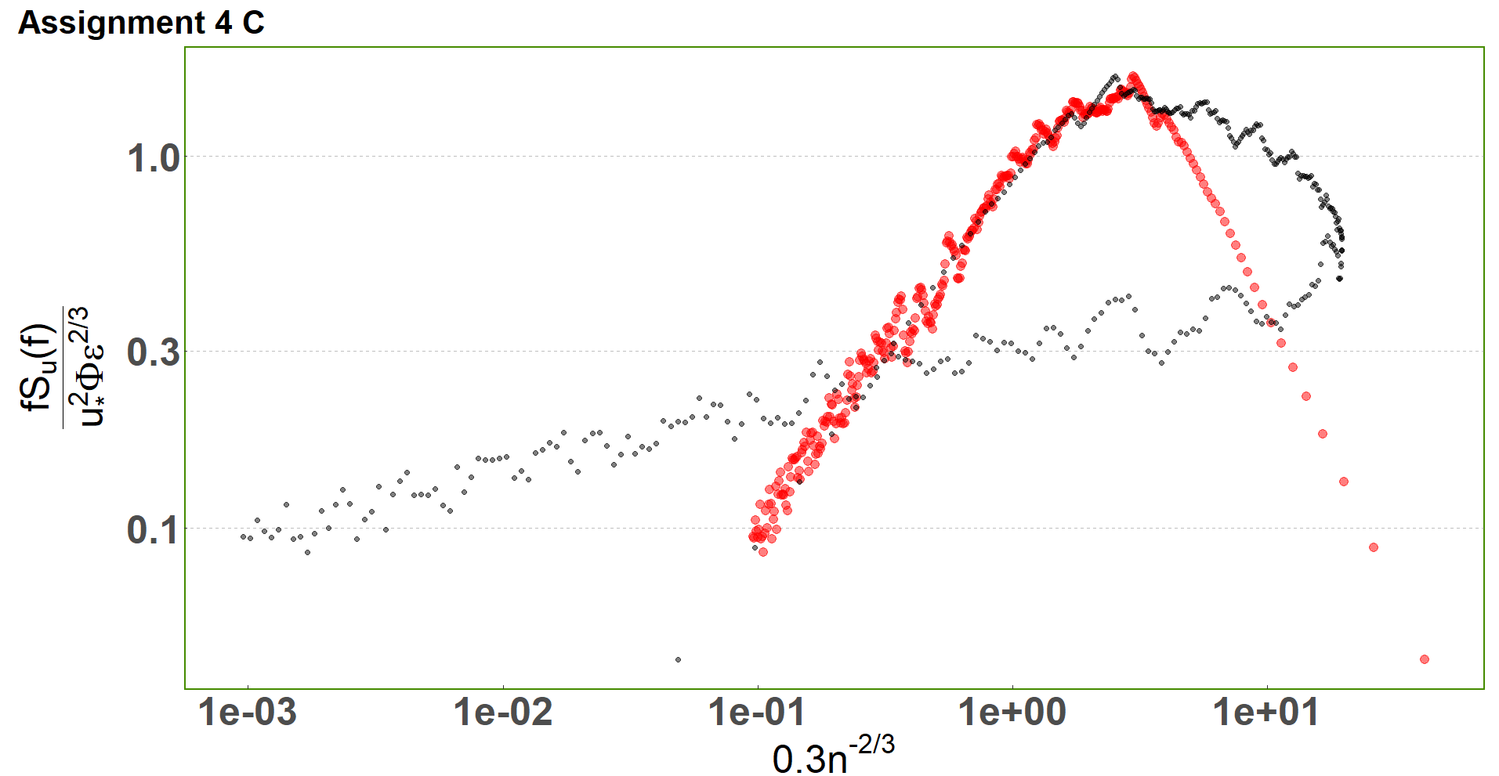

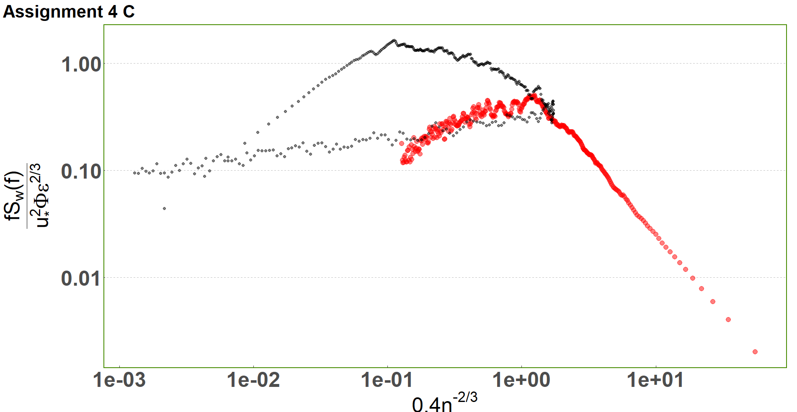

Lower limit of the inertial subrange would be 0.27 when n =0.3 if we assume z = 3m, u = 2.71m/s from assignment 3 a

Sv/Su

Sw/Su

Fig 5.1 Sw,v/Su

When n =0.3, f = 0.27, Su(f) = 0.086641, so the dissipation rate is 0.0065

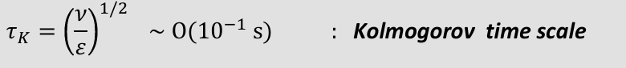

Tau(k) = 0.0484 s , and 𝑓k= 20.64 /s, and the max f in our data is 5 /s, so our data does not extend into dissipation range